Seachtain Náisiúnta na gCrann 2013
National Tree Week 2013

‘The Sound of Trees’
Fuaim na gCrann

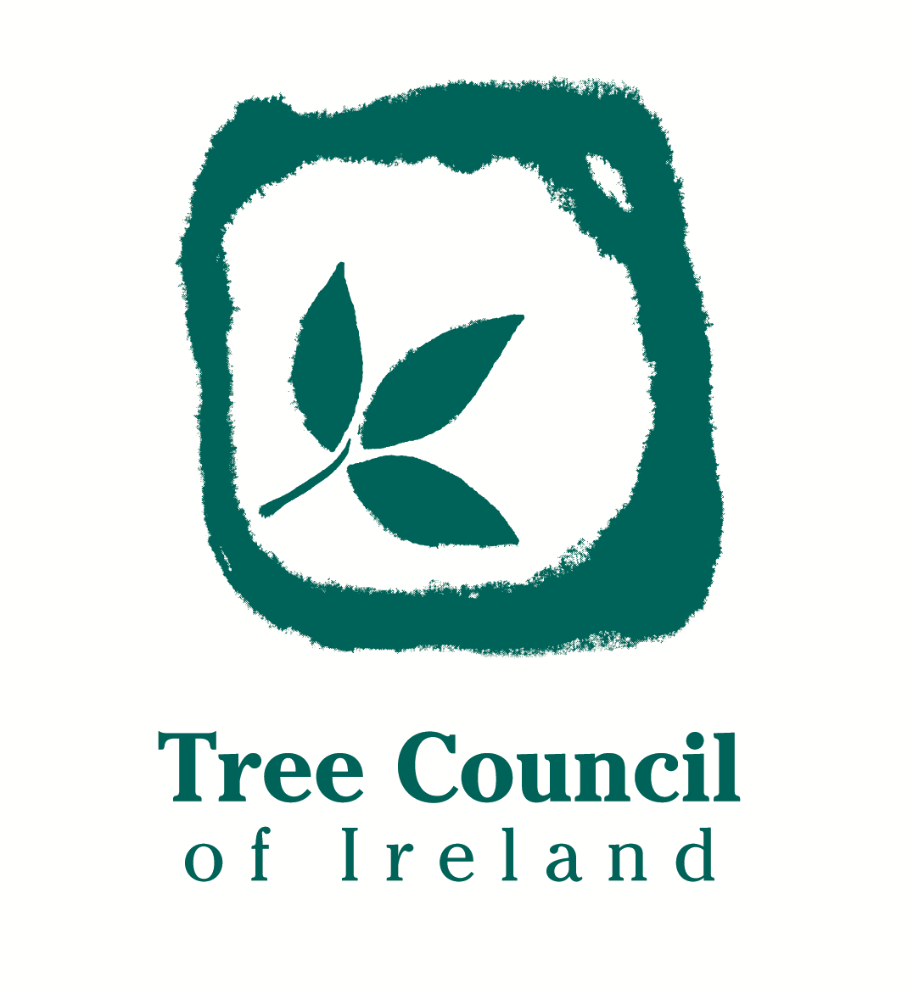

National Tree Week, which is organised by the Tree Council of Ireland and supported by SSE Airtricity, will take place this year from
2 - 8 March 2014. The theme is ‘The Sound of Trees’, to remind people of the role of trees in our lives not just visually.
To be part of National Tree Week, the Tree Council of Ireland invites you to organise one or more events for the week. As well as tree planting ceremonies, the range of events can include forest and woodland walks, nature trails, workshops, woodturning displays, listening to the trees and what lives in the trees. Talks, tree climbing, broadcasts, launches, concert ‘The sound of Trees’ poetry readings, exhibitions, dramas, free trees donated by Coillte.

Don't forget to register your event! You can do so via the Tree Council’s website, www.treecouncil.ie or complete the attached form and submit it preferably by email to trees@treecouncil.ie or by post to The Tree Council of Ireland, Seismograph House, Rathfarnham Castle, Dublin 14, Phone: 01-4931313. To ensure maximum exposure and promotion for your event, please submit your event details by Friday 20th February. You can also advertise your own event by downloading the free National Tree Week 2014 poster from the Tree Council’s website www.treecouncil.ie which will be available to download from early February.

We would like to thank you in advance for promoting an awareness of Trees and National Tree Week.
Best Wishes,

The Tree Council of Ireland

____________________________________________________________________

EVENT DETAILS

Title of Event: ___________________________________________________________

Venue: ____________________________________________________________

Date and Time: __________________________________________________________

Organising body/ies: _____________________________________________________

Contact person: __________________________________________________________

Tel: _________________ E-mail: _________________ Website____________

Short description/details of Event:

Please use a separate sheet for each event

Previous events include: Exhibitions, Walks, Tours, Talks, Tree Planting, Presentations, Launches, Readings, Broadcasts, Demonstrations, Drama, Renovations, Competitions, Nature Trails, Tree Dressing, Tree Hugging, Tree Climbing…

Imagination is the only Limitation!

